表面化学动力学课程

Chemical Dynamics at Surfaces

Instructor: Professor Daniel J. Auerbach

# Goal

The goal of this field is to interpret macroscopic surface chemistry with first principles concepts at an atomic level. The course describes basic concepts needed to understand surface chemistry as well as modern experimentation employed to probe the limits of this understanding.

# Outline

1. Early Work on reactions at surfaces
   1. Historical background – early work on surface chemistry and the discovery of catalysis
   2. Importance of Catalysis: Haber-Bosch process of ammonia synthesis
   3. Irving Langmuir and birth of modern surface chemistry
2. Framing the Problem: formulation of the modern approach
   1. Born-Oppenheimer Approximation and potential energy surfaces (PES)
   2. Standard Model of Chemical Reactivity
3. Gas phase reaction dynamics – methods to probe the PES
   1. Energy requirements and energy disposal
   2. Molecular beam techniques
   3. Comparison to ab initio theory
4. What is different about surface dynamics
   1. Complex target: geometrical structure, electronic structure, phonons, electron hole pairs
   2. The need for Ultra High Vacuum (UHV) and surface analysis
5. Energy transfer processes involving phonons in non-reactive systems
   1. Molecular Translation (T) coupling to phonons (ph), rotation (R), vibration (V)
   2. Trapping and detailed balance
6. Energy transfer processes involving electron hole pairs
7. Adsorption and Desorption
   1. Desorption kinetics and binding energies
   2. Adsorption / Desorption dynamics and detailed balance
8. Reactive Processes at Surfaces
   1. reaction mechanisms from kinetics
   2. reaction mechanisms – dynamics
9. Professional Model of Surface Reactions Dynamics
   1. Comparison of experiment and ab initio theory
10. Reactions of radicals with surface

**Prof. Daniel J. Auerbach**

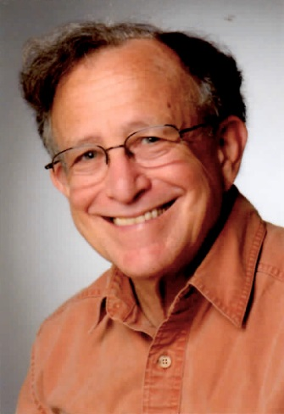

Daniel Auerbach is perhaps best known as a pioneer in the application of molecular-beam and laser-spectroscopic techniques to reveal the microscopic details of chemical dynamics at surfaces. His research interests also include information storage systems, the design of parallel computers, and chemical reaction dynamics.

Auerbach is currently a scientific co-worker and visiting professor at the Max Planck Institute for Biophysical Chemistry and the Leiden Institute of Chemistry. Previously he was Chief Technology Officer of Gas Reaction Techniques Inc., worked for many years in the microelectronics and computer industry for IBM and Hitachi Global Storage Technologies, and was on the faculty of the Johns Hopkins University.

At IBM, Auerbach served for 10 years as Department Group Manager of the Science and Technology Department at the IBM Almaden Research Center. Under his leadership, this department made many important contributions to IBM technology and to science including the development of the first GMR sensor for HDD applications, the development of resists and other key materials for microelectronics applications, the first fabrication of structures by manipulation of individual atoms, broad ranging contributions to surface science and chemical dynamics at surfaces, and the early development of methods to use loosely coupled parallel computers for scientific problems.

Auerbach holds a Ph.D. degree in Physics from the University of Chicago. He is a fellow of the American Physical Society, the American Association for the Advancement of Science, and the American Vacuum Society and received the AVS Gaede-Langmuir award in 2008.